MEDICAL INVENTORY MANAGEMENT

## College Name: KPR COLLEGE OF ARTS SCIENCE AND RESEARCH

## College Code: bruaz

TEAM ID:0222D52D670696DA56846FCE84F9B4DE

TEAM MEMBERS:5

Team Leader Name: HARIRAGHAVAN T

Email:[23bcs026@kprcas.ac.in](mailto:23bcs026@kprcas.ac.in)

Team Member1: ABHINAV R

Email:[23bcs001@kprcas.ac.in](mailto:23bcs001@kprcas.ac.in)

Team Member2: HARIKARAN S

Email:[23bcs025@kprcas.ac.in](mailto:23bcs025@kprcas.ac.in)

Team Member3: JEEVITH S

Email: [23bcs029@kprcas.ac.in](mailto:23bcs029@kprcas.ac.in)

Team Member4: KAVIYARSU M

Email: [23bcs033@kprcas.ac.in](mailto:23bcs029@kprcas.ac.in)

# INTRODUCTION

Project Overview

This project is a comprehensive Salesforce application to streamline and manage various operational aspects of medical inventory. The system aims to efficiently maintain supplier details, manage purchase orders, track product details and transactions, and monitor the expiry dates of products. Maintain detailed records of suppliers, including contact information. Catalog product information, including descriptions, stock levels. Monitor and track product expiry dates to avoid using expired items. Comprehensive reports to track supplier performance, and purchase orders.

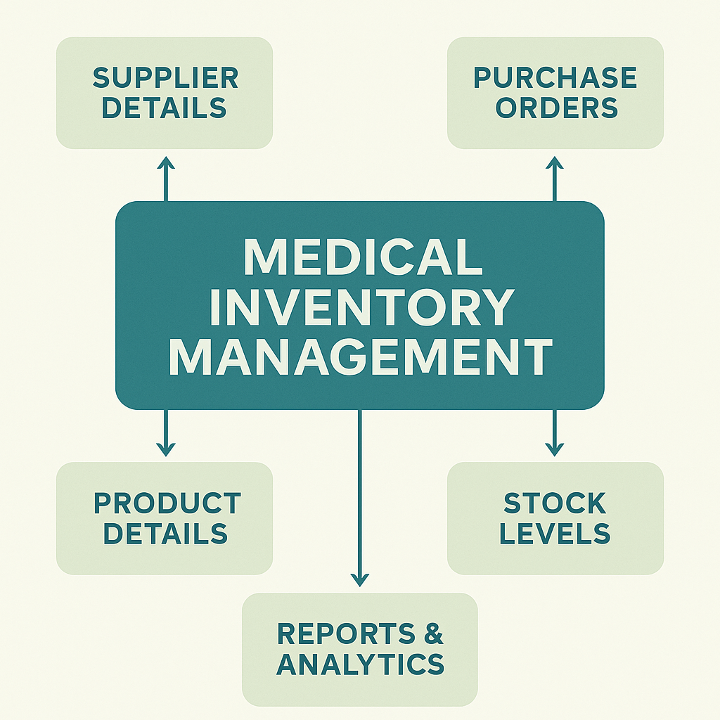

Purpose  
The purpose of this project is to develop a Salesforce-based medical inventory management system that ensures efficient tracking of suppliers, purchase orders, product details, and expiry dates. It aims to streamline operations, reduce errors, prevent the usage of expired items, and provide comprehensive reports for better decision-making and supplier performance evaluation.

DEVELOPMENT PHASE

Creating Developer Account:

By using this URL - <https://developer.salesforce.com/signup>.

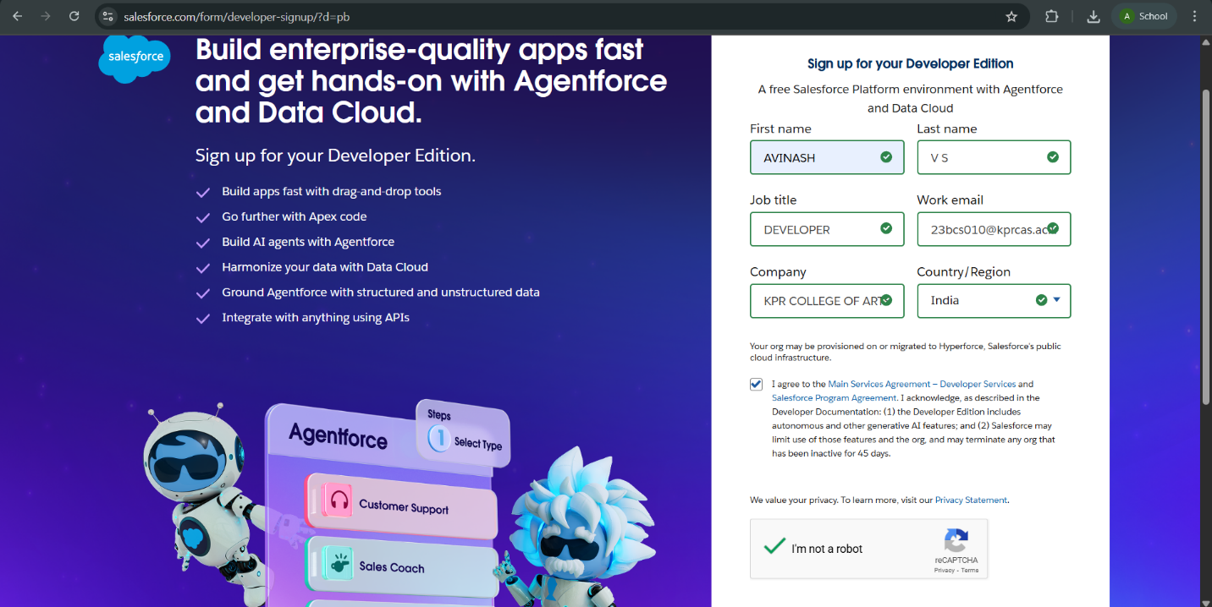

* After creating developer account,Go to setup page and create the object.

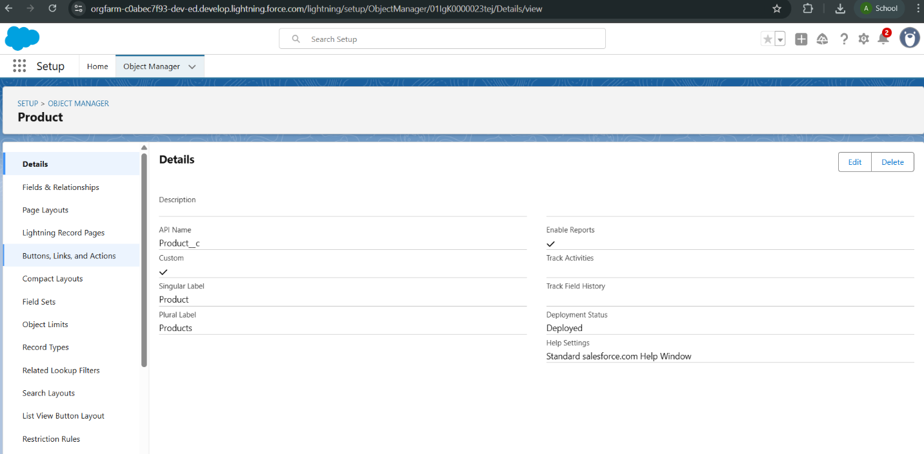

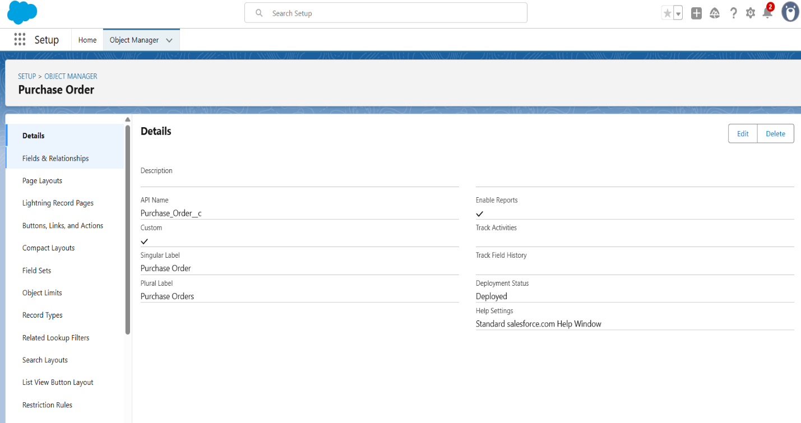

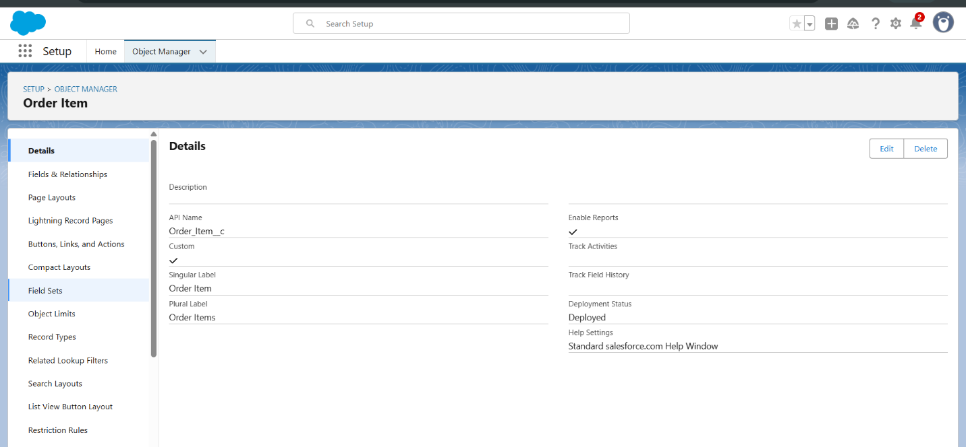

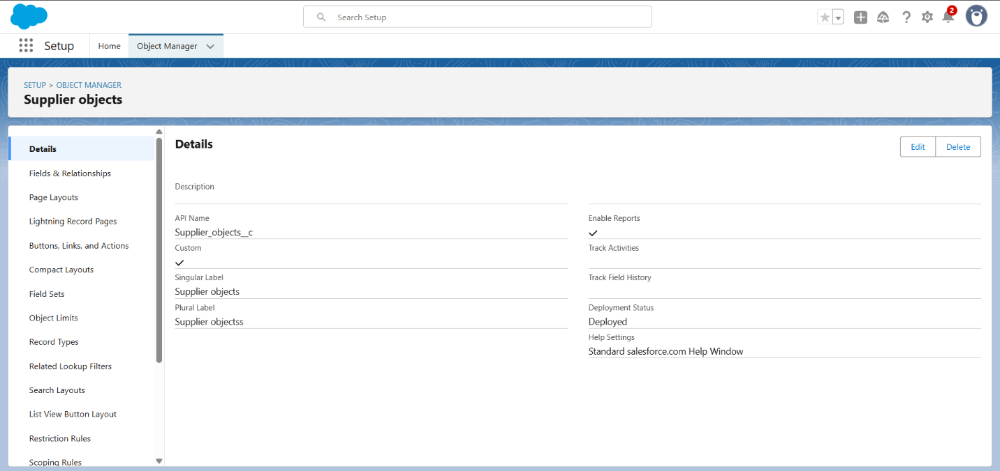

* All the given objects has been created.
* Created the five tabs inventory transaction,order item,product,purchase order,supplier objects.

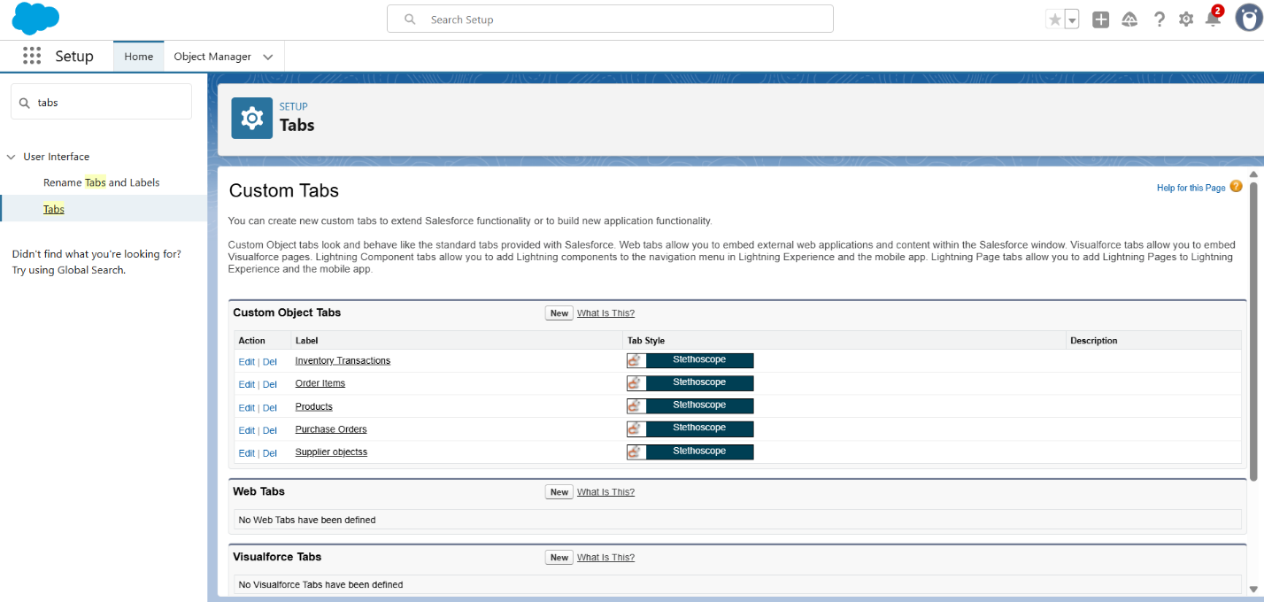

* Created a lightning app for Medical Inventory Management.

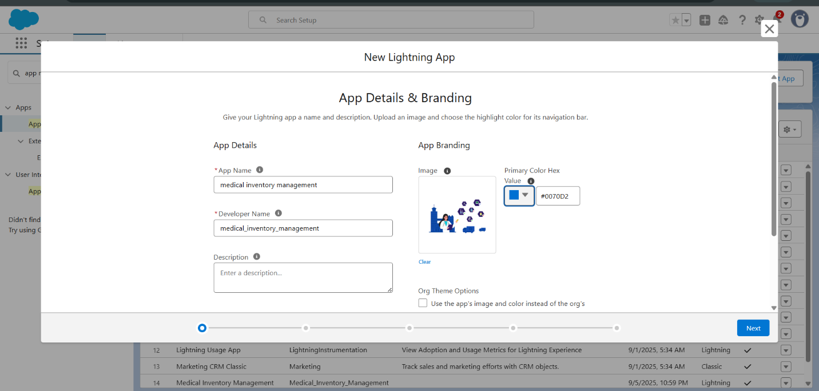

* Created a text field in product object.

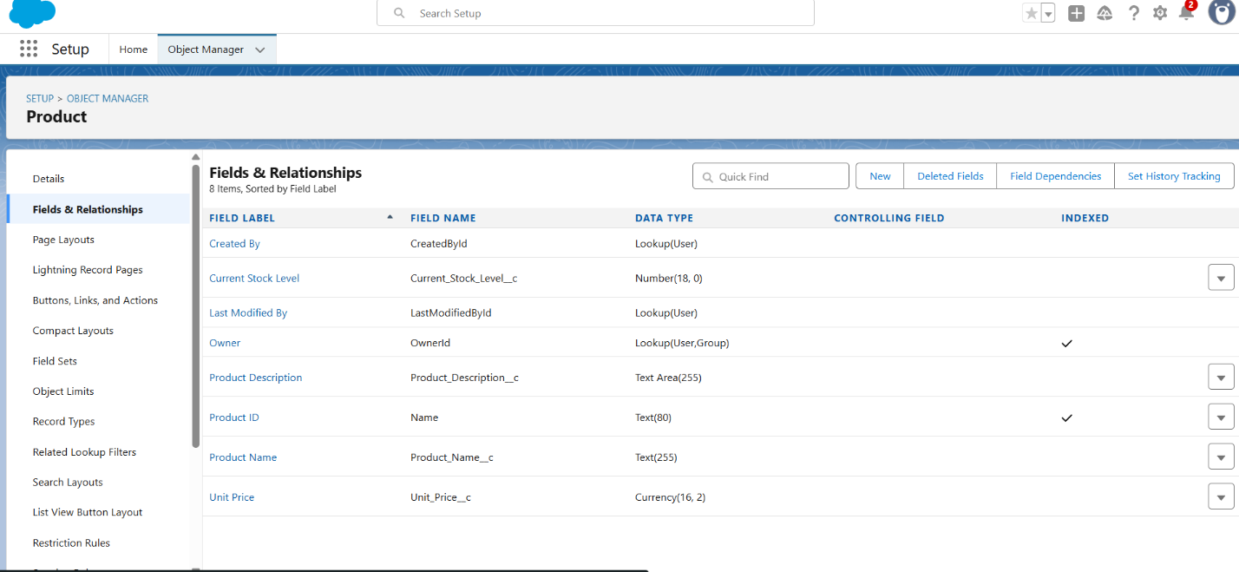

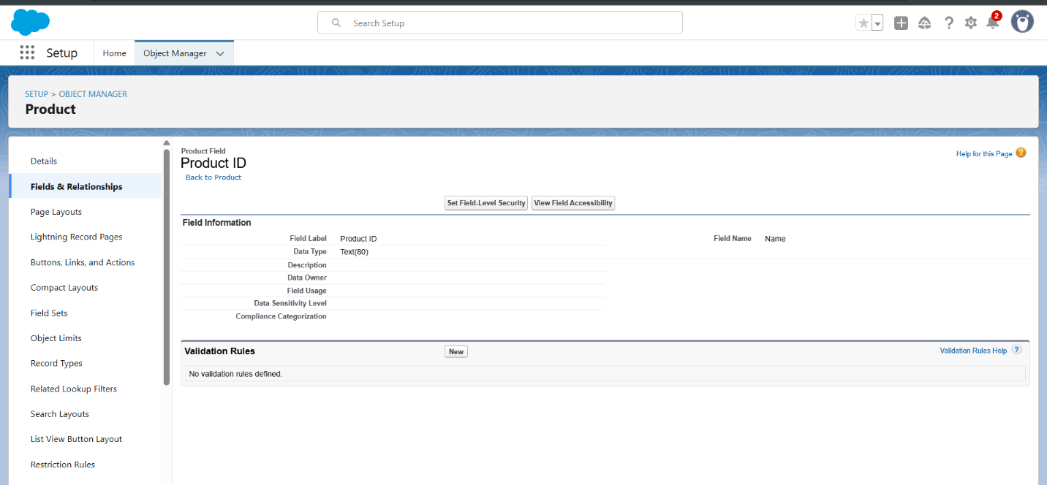

* Created a textArea in product object.

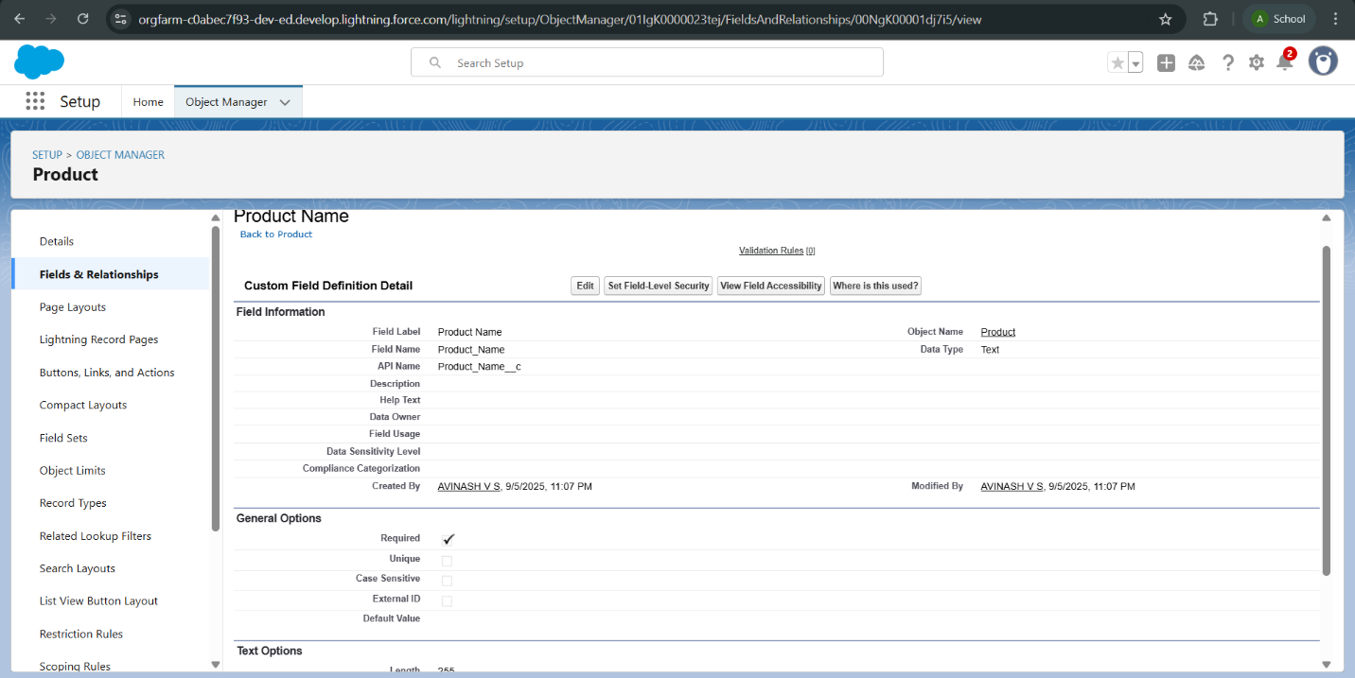

* Created a number field in product object.

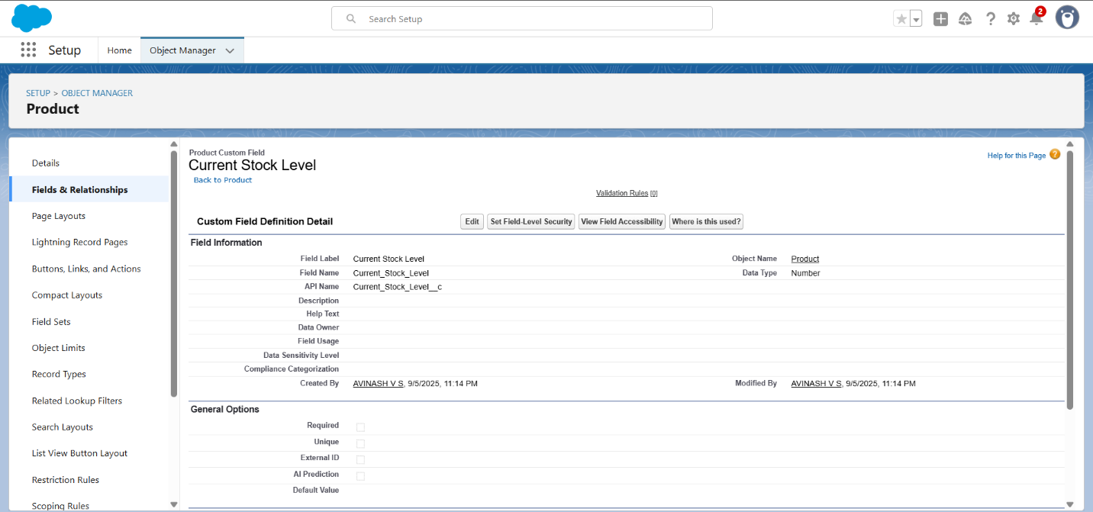

* Created a currency field in product object.

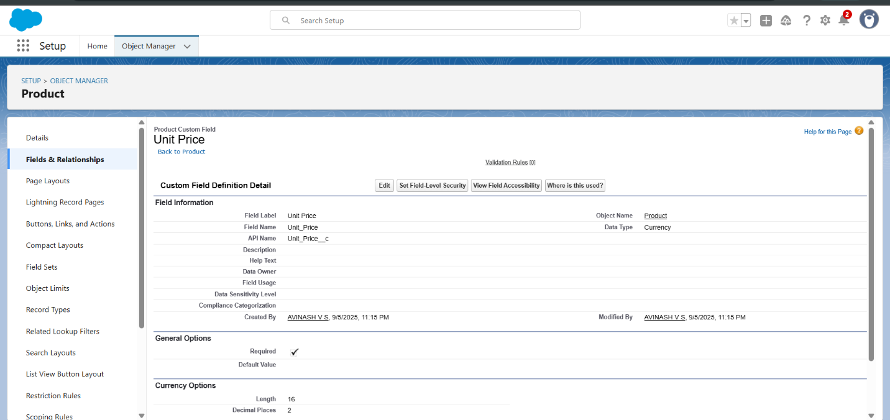

* Created a lookup relationship,date field,roll up summary in purchase order.

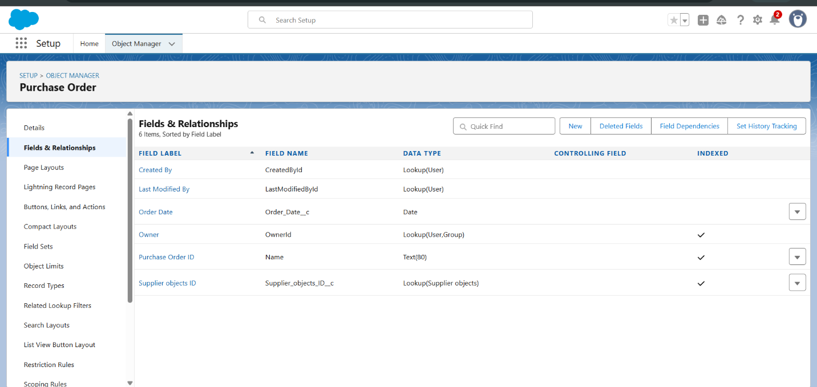

* Created a unit price formula, amount formula field in order item.

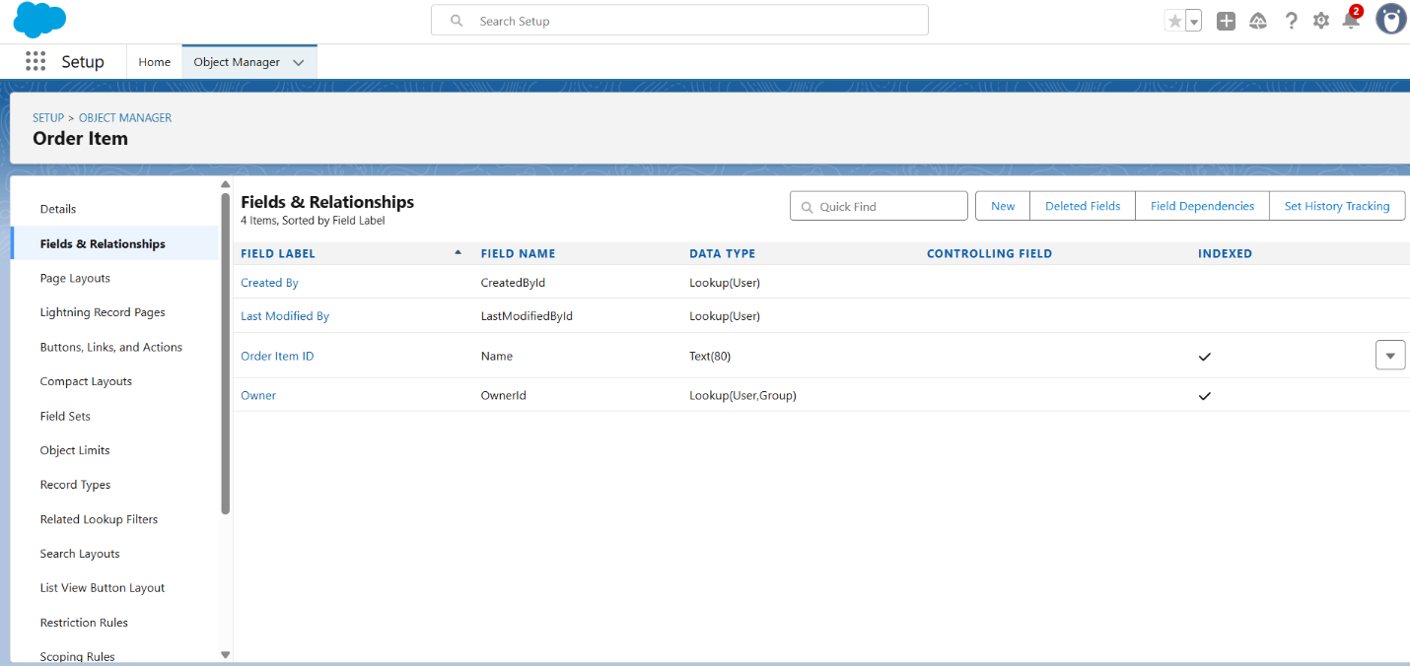

* Created a picklist, total order cost field in inventory transaction .

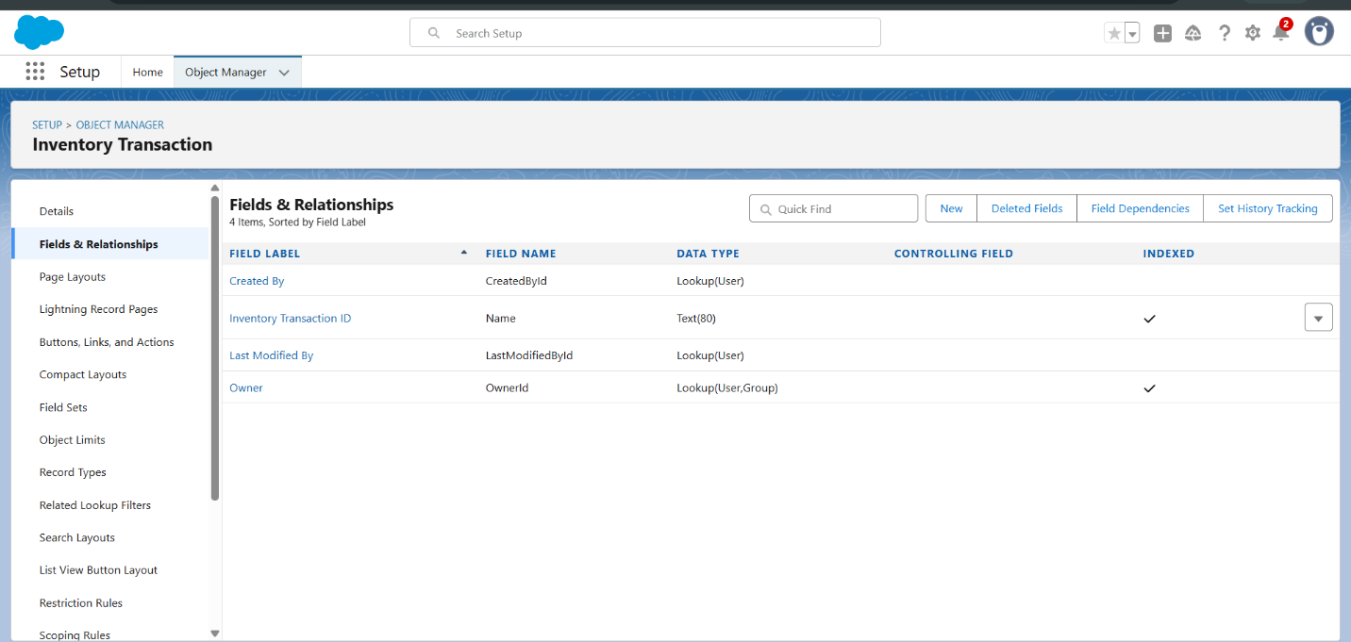

* Created a phone,email field in supplier object .

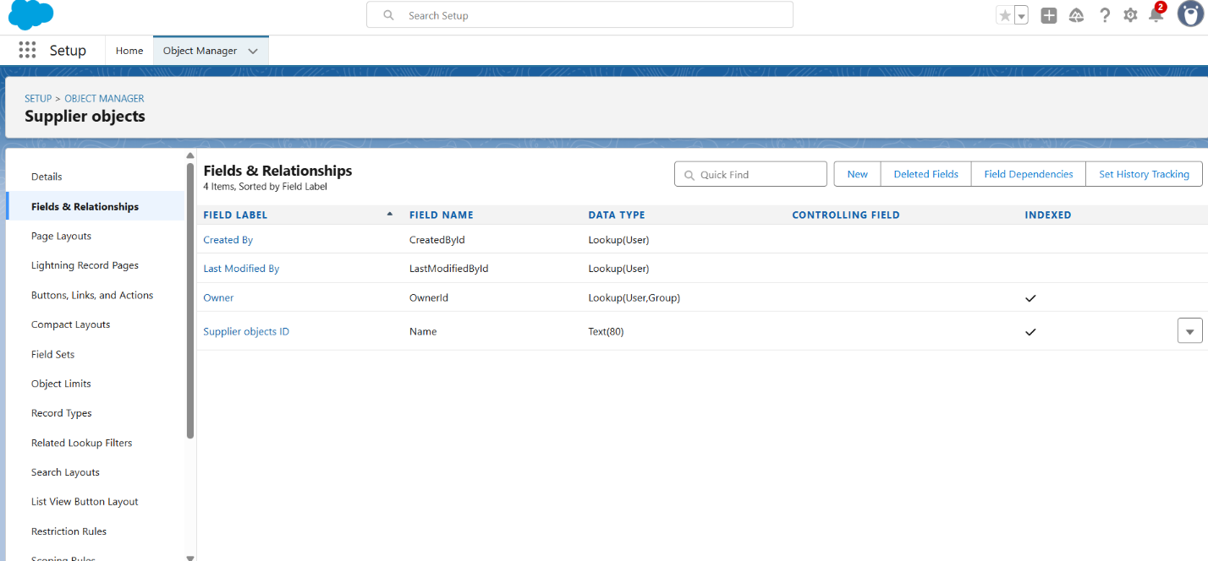

* Edit page layouts in product,purchase order,order item,supplier object,inventory transaction.

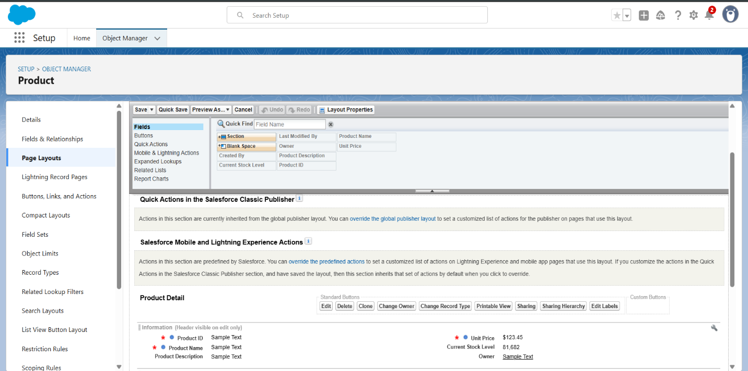

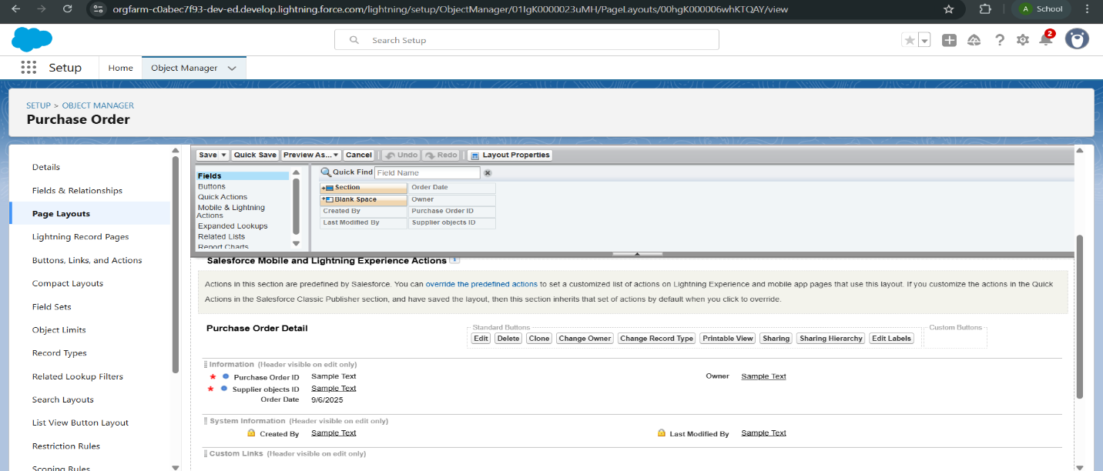

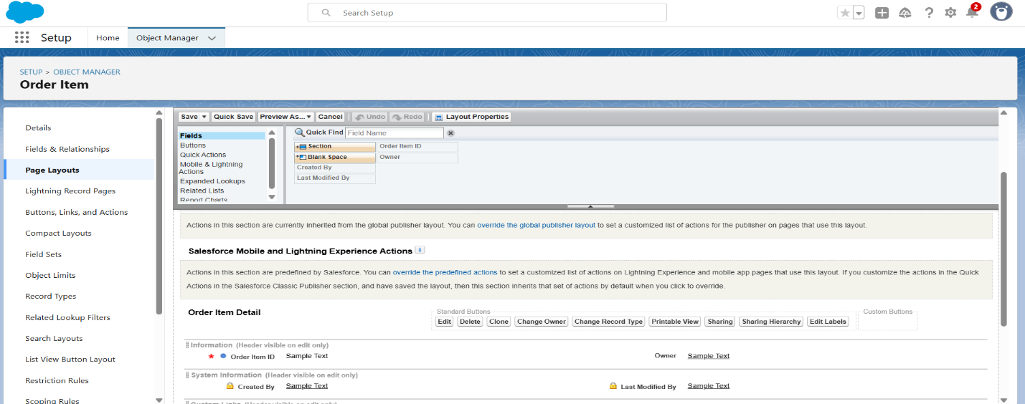

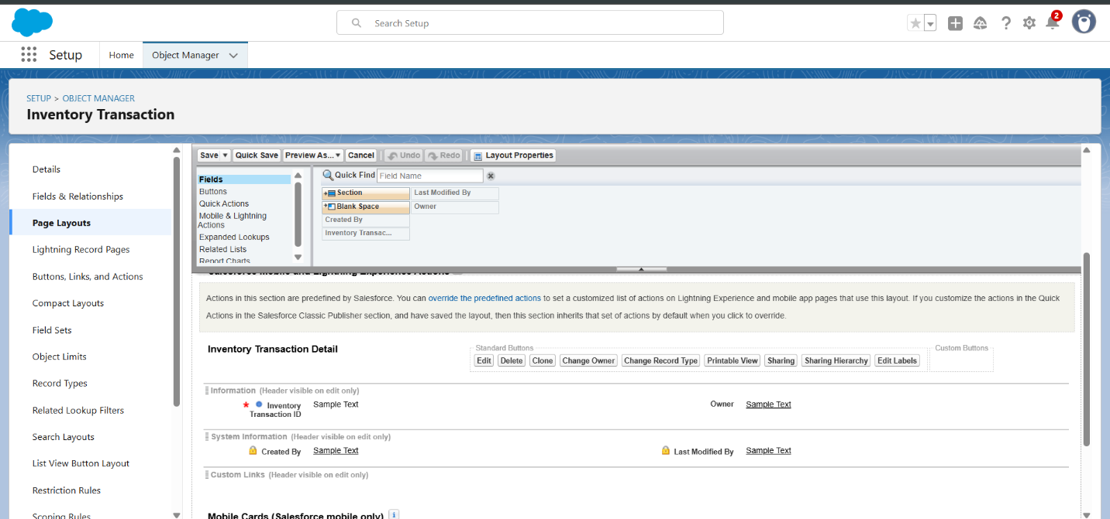

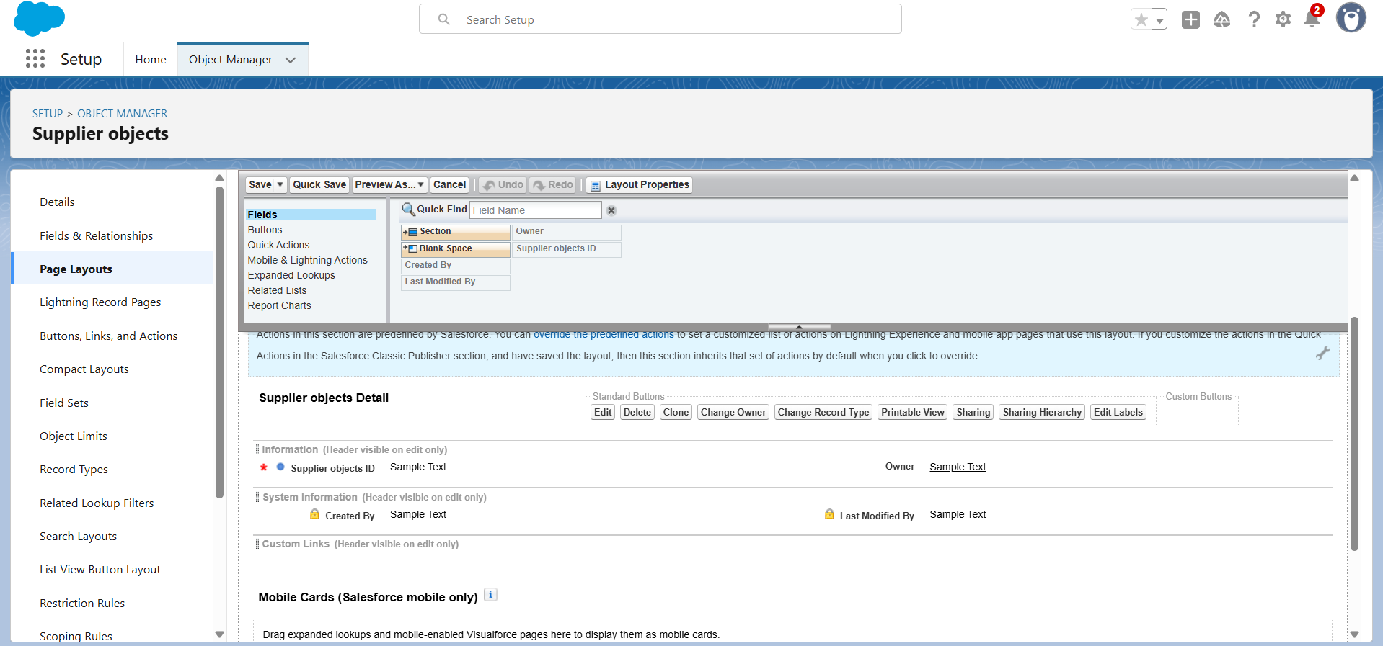

Compact layout

* Created compact layout for product.

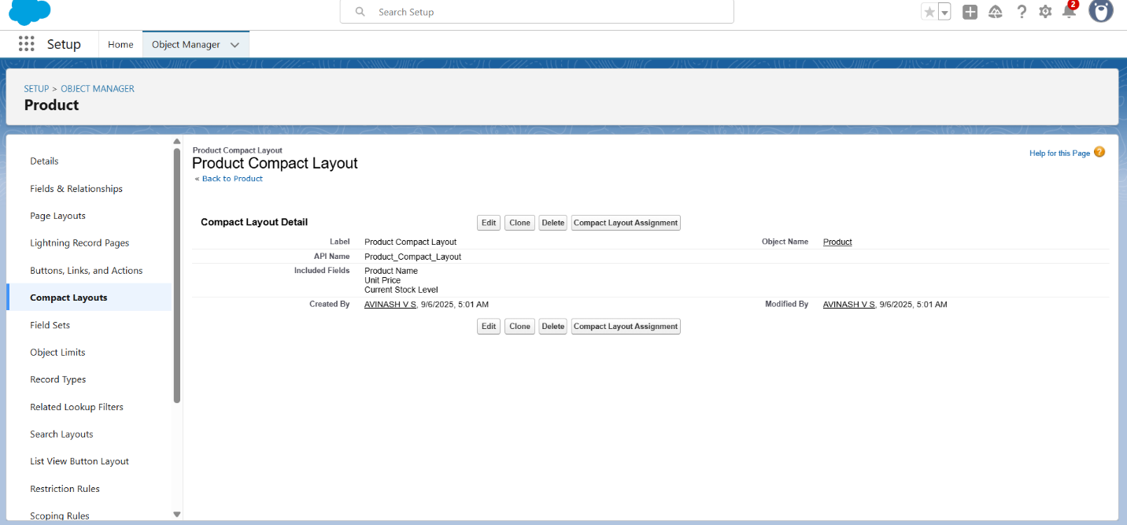

* Created compact layout for purchase object.

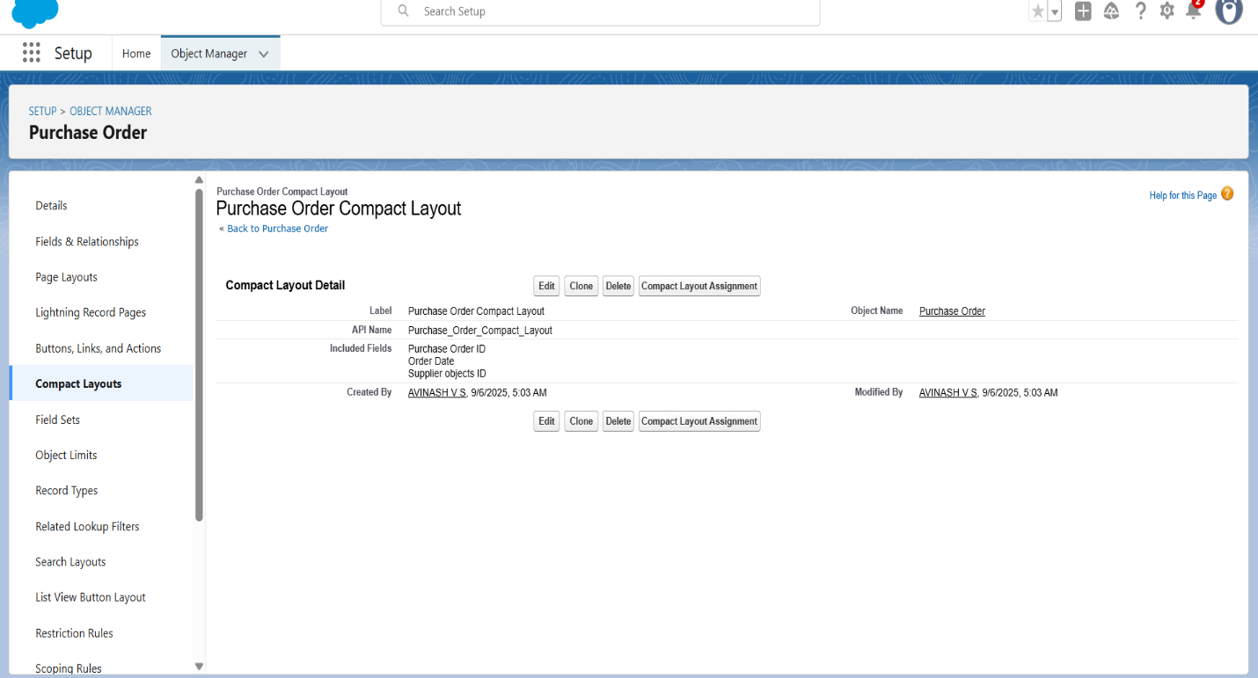

Validation rules

* create an Expected Delivery Date Validation rule to a Employee Object.

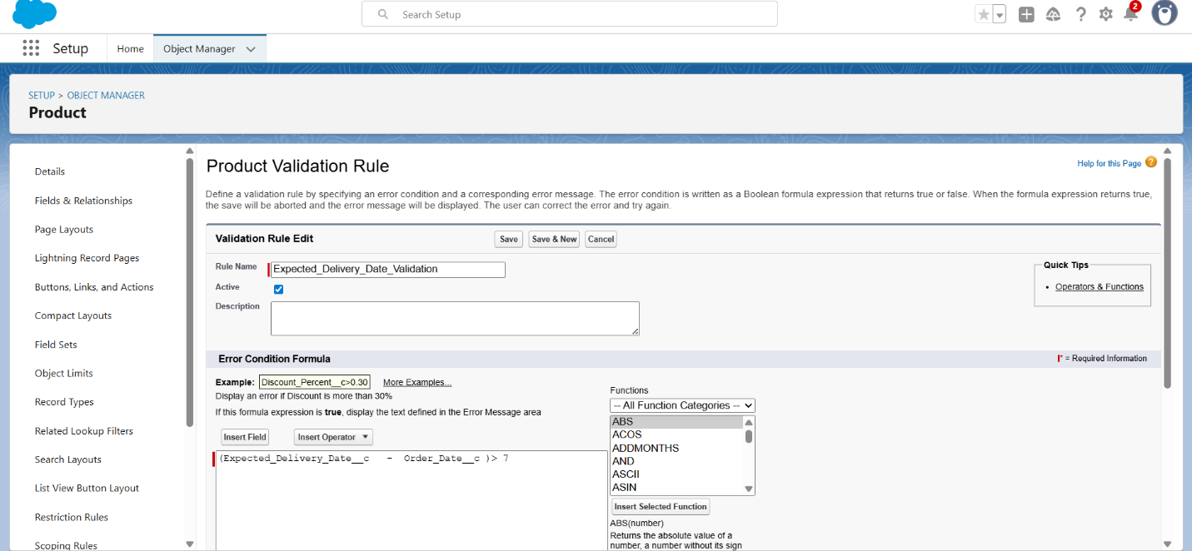

Profile

* created an inventory and purchase manager profle.

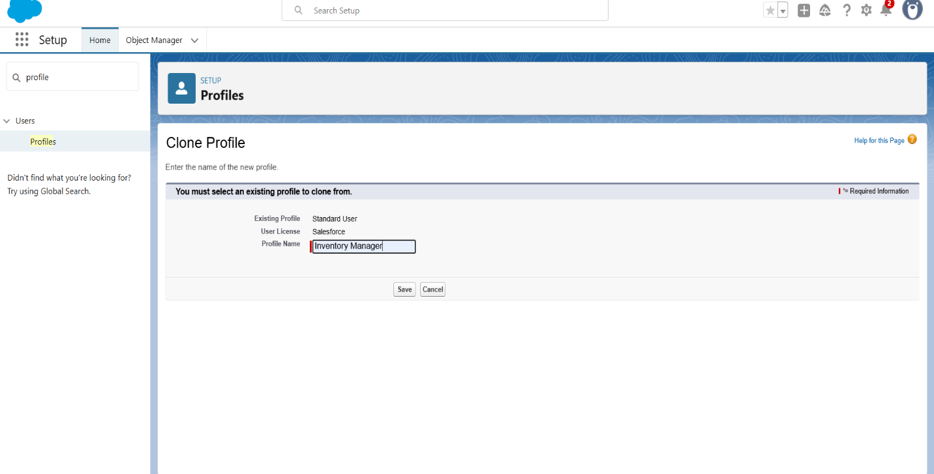

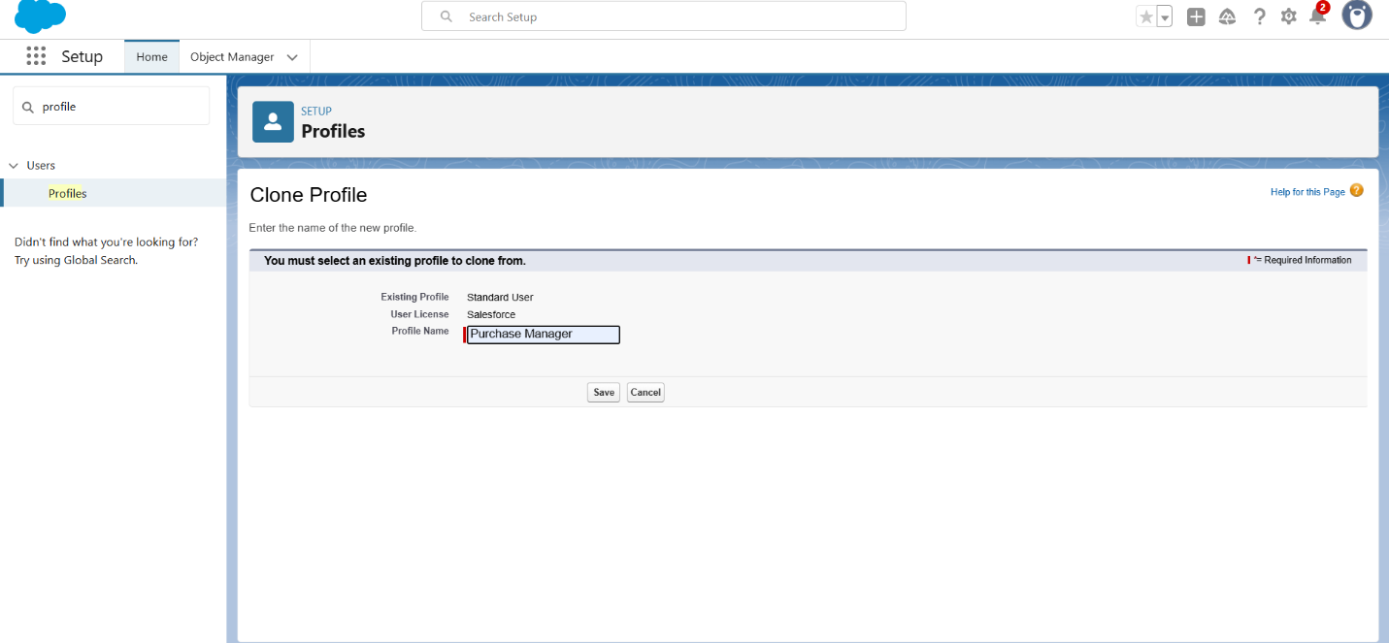

Role

* To create a purchasing manager role.

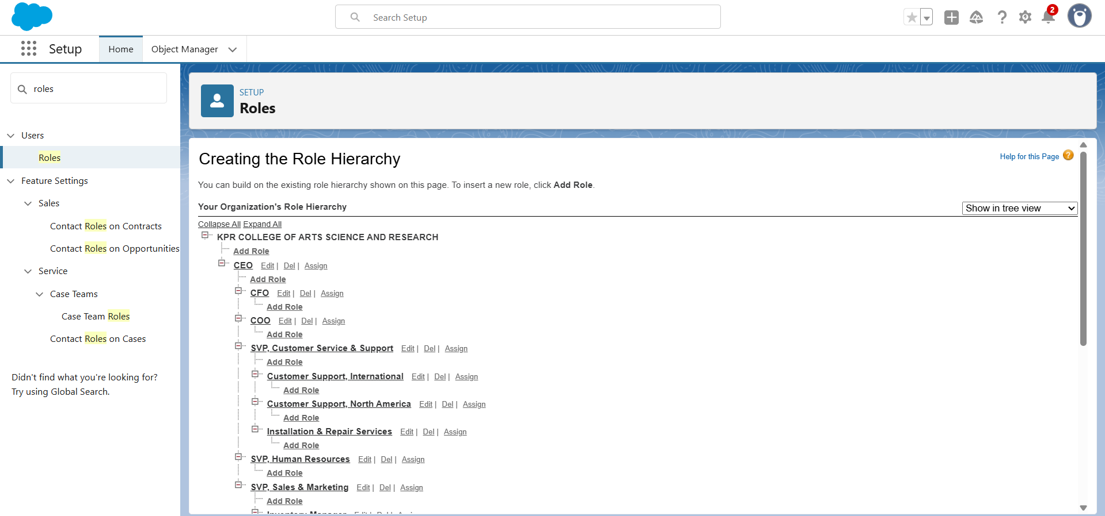

* Created a permission set.

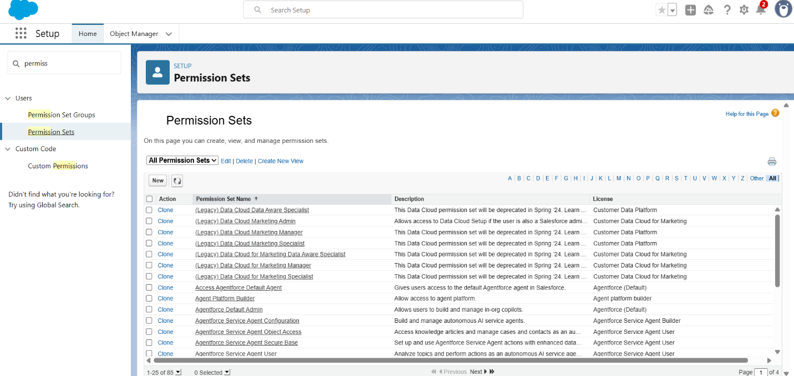

Flows

* Created Flow to update the Actual Delivery Date.

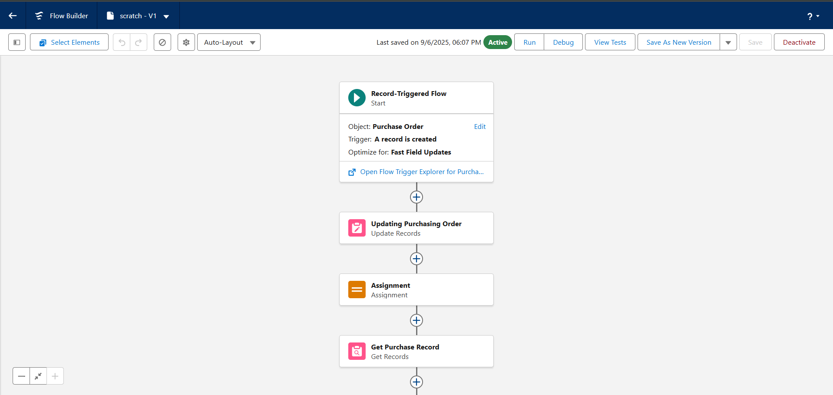

Apex Triggers

* Created a Trigger to Calculate total amount on Order Item.

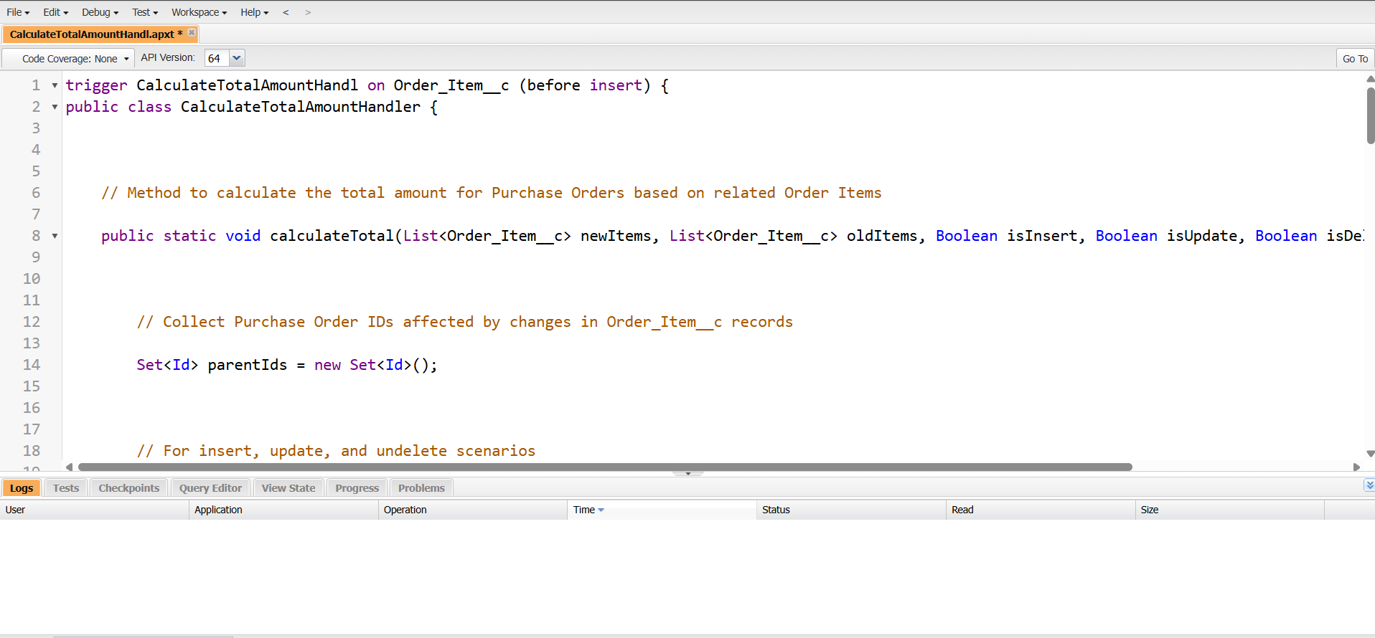

Report

* Create a Purchase Orders based on Suppliers(Summary) Report

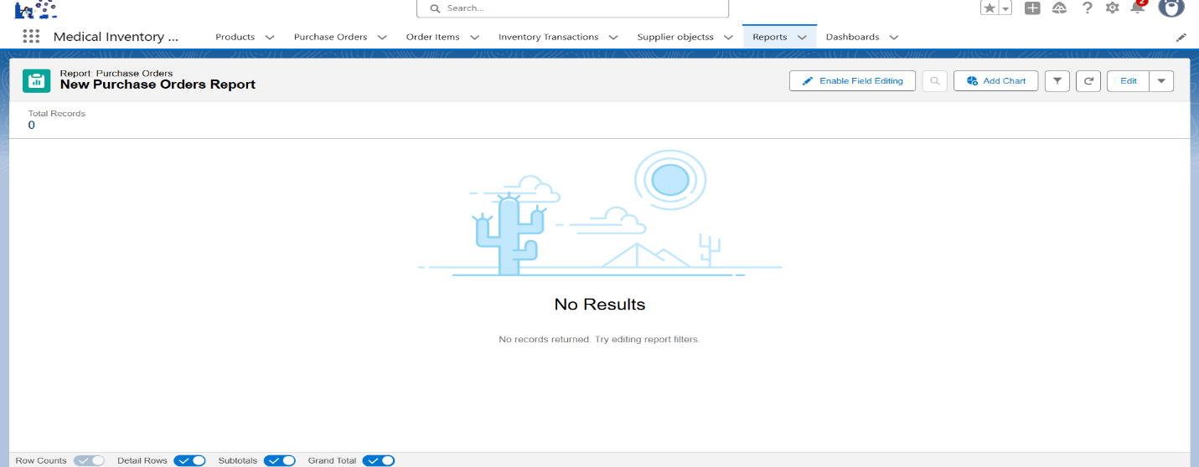

* Create a Complete Purchase Details Report

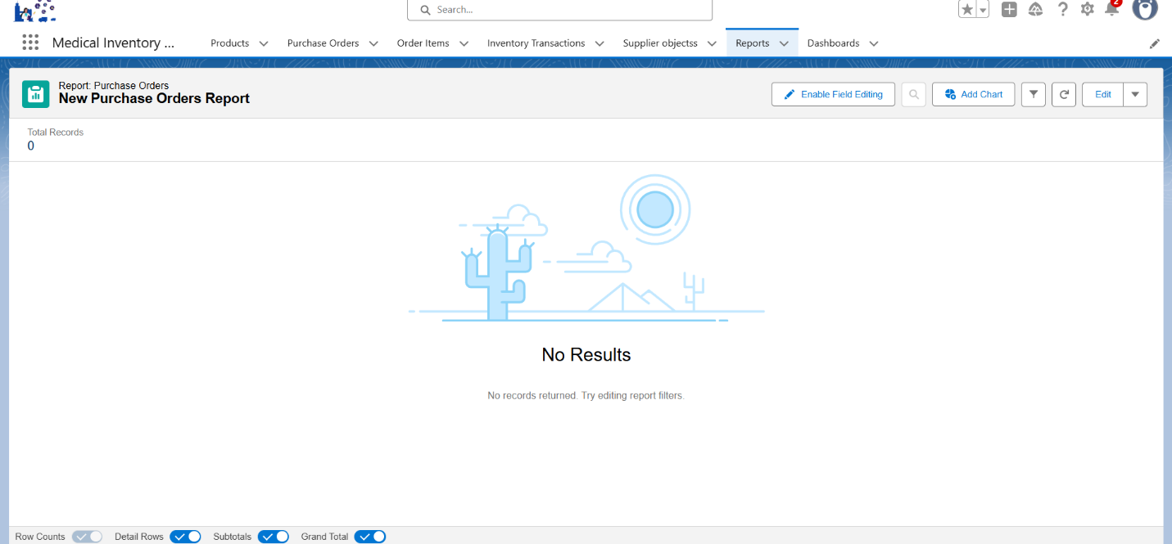

Dashboard

* Created Dashboard

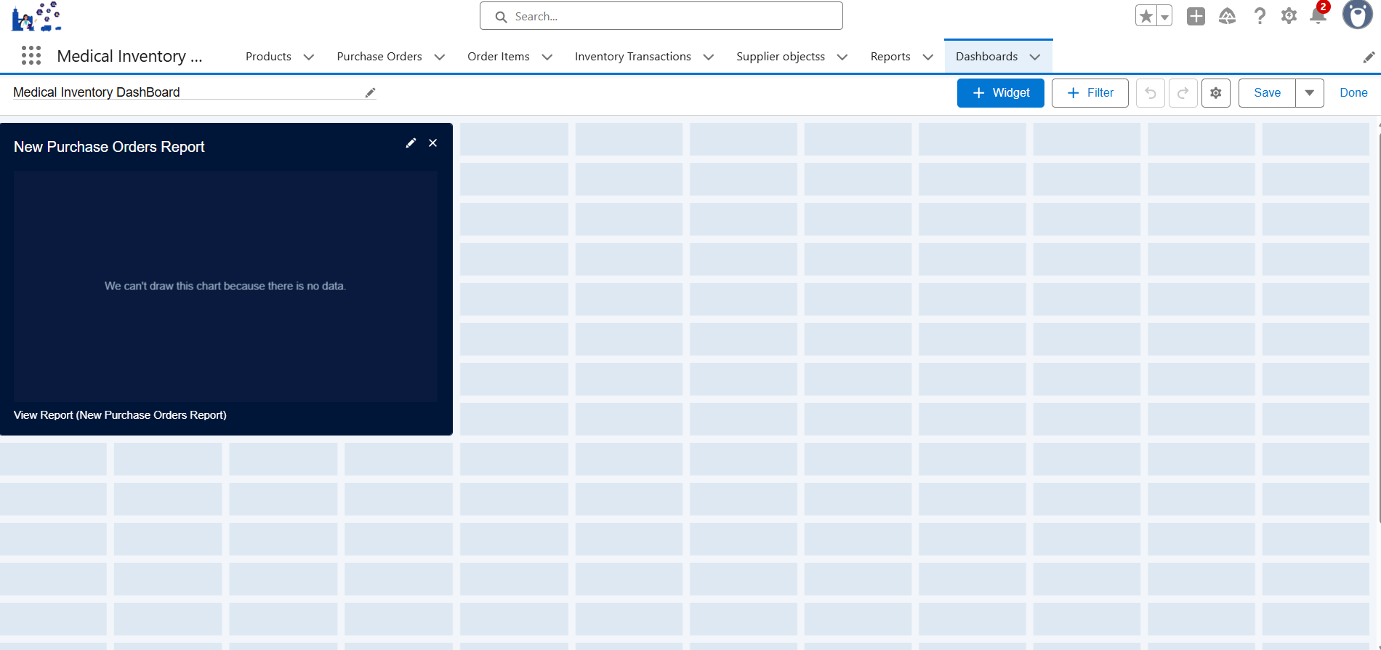

* To view the dashboard

